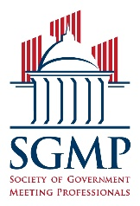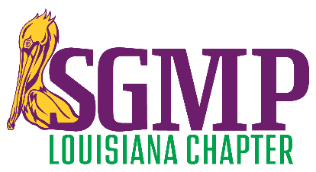

2021 SGMP CHAPTER BOARD CALL FOR NOMINATIONS

The Louisiana Chapter of the Society of Government Meeting Professionals is looking for leaders! Nominations are now being accepted for all five elected positions* on the 2021-2023 Louisiana Chapter Board of Directors. The incoming chapter board shall be sworn in during the June 10th chapter education meeting/event. Their term of office will run from July 1, 2021 through June 30, 2023.

If you wish to be considered as a candidate, or wish to nominate a fellow member, the nomination form and information on the nominations & elections process may be found on our website at https://sgmpla.net/Nominations-&-Elections/ . The nominations period will remain open until 5:00pm local time on March 12, 2021.

The chapter’s Nominations & Elections Committee is responsible for arranging and overseeing the chapter elections process. Should you have any additional questions, contact LeAnna Toups-Bennett, the committee chair, at President@sgmpla.net.

Any chapter member in good standing for at least six months (in the category noted below) prior to nomination shall qualify for nomination to and election on the chapter board of directors:
President Government Planner or Contract Planner

First Vice President Government Planner or Contract Planner

Second Vice President Supplier

Secretary Government Planner or Contract Planner

Treasurer Supplier or Contract Planner

Directors (3)* (1) Government Planner; (1) Supplier;
(1) Government Planner, Contract Planner, or Supplier
*The Chapter Director positions were eliminated from the elections process when the chapter elected to have the variance of a five member elected board.

SGMP has made several revisions to the bylaws and policies affecting chapter elections since this chapter’s last election. This year’s timeline has also been revised. Key nominations & elections process deadlines this year are the following:
- Chapter nominations must close by 03/12/2021
- Chapter membership online voting opens on 03/25/2021
- Chapter membership online voting closes at 4:00pm CST on 03/31/2021
- Chapter election results are announced to entire chapter by 04/02/2021
- New chapter board members must be installed by 06/30/2021
- Code of Ethics form (signed by all new chapter board members) must be received at SGMP by 07/31/21

