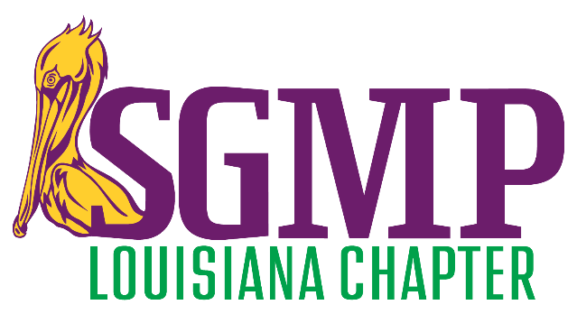
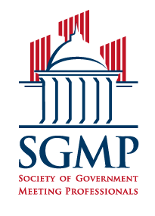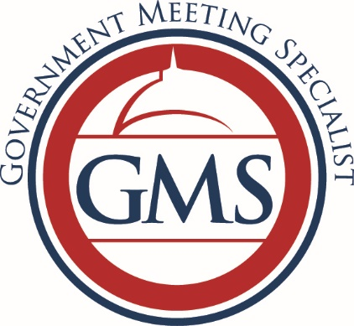
The Society of Government Meeting Professionals and <<Chapter Name>>

confirms that

<<FirstName>> << LastName>>

having duly qualified under the recognized standards of competence as prescribed, and having
fulfilled all the personal, ethical, and professional requirements as established by SGMP has hereby completed the

Government Meeting Specialist (GMS)

certificate program and is entitled to all rights and privileges as determined by SGMP.

Certificate Date:

______________________________
Sharon Delvisco, CGMP, GMS, LMSW, DSW
Chapter President

