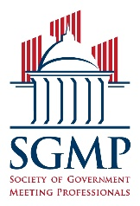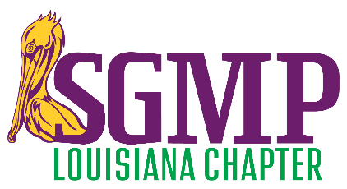
2021 SGMP LOUISIANA CHAPTER BOARD NOMINATION FORM

Any member may nominate himself/herself or a fellow chapter member, but the nominee must submit this completed and signed form by 03/12/2021 to the Chapter Nominations & Elections Committee Chair at President@sgmpla.net with “Chapter Nominations & Elections” in the subject line.

NOMINEE INFORMATION

FIRST AND LAST NAME ___________________________________________________

EMPLOYER ___________________________________________________

EMAIL ADDRESS ___________________________________________________

CONTACT NUMBERS* ___________________________________________________
*Any nominee may be contacted for additional information during this period
*All candidates will be directly contacted with their election result prior to public announcement

POSITION(S)

- Any individual may be nominated for multiple positions but may only be a candidate for one position
- All nominees will have the final say on the position for which they would become a candidate
- All terms of office are two years—from 07/01/2021 through 06/30/2023.

Please indicate your selection below with an X on the line.

___ President Government Planner (GP) or Contract Planner (CP)
___ First Vice President GP or CP
___ Second Vice President Supplier (S)
___ Secretary GP or CP
___ Treasurer CP or S

NOMINATION ELIGIBILITY CRITERIA
- The national headquarters must confirm that any individual who accepts a nomination is membership eligible by being an SGMP member in good standing for at least six months prior to this nomination.
- The nominee must confirm that he/she has received supervisor support and can do this simply by including his/her supervisor’s contact info below (this support is subject to verification by SGMP).
- The nominee must confirm that he/she will abide by the SGMP Chapter Board of Directors Code of Ethics (page 2 of this form is a code of ethics summary) and can do this simply by signing below.

_______________________________________________ ___________________________________
Nominee’s Signature Signature Date

_______________________________________________ ___________________________________
Supervisor’s Printed Name Supervisor’s Phone Number
2021 SGMP LOUISIANA CHAPTER BOARD NOMINATION FORM

The Principles of the Code of Ethics of the Society of Government Meeting Professionals

As board member at the chapter level of the Society of Government Meeting Professionals (SGMP), I will recognize the importance of codifying and making known to the profession and to the membership at large the ethical principles that guide the work of the Chapter Board in providing information, services, and leadership to the Society.

Ethical dilemmas occur when values are in conflict. SGMP’s Code of Ethics states the values to which I am committed and embodies the ethical responsibilities of conduct as a Chapter Board member.

The chapter board significantly influences or controls the selection, organization, preservation and dissemination of information and leadership through the guidance of the SGMP bylaws and policies. In our organizational system, grounded in government and professional ethics, all Chapter Board members will be explicitly committed to carrying out the responsibilities of our elected office to the best of our abilities. I will have a special obligation as an elected official to guide SGMP and our chapter in its present course and to ensure the free flow of information and ideas to foster the future growth of the Society to benefit its members.

The principles of the SGMP Code of Ethics are expressed in broad statements to guide ethical decision-making and actions (the “we” below represents the chapter board of directors). These statements provide a framework; they cannot and do not dictate conduct to cover particular situations.

I. We provide the highest level of service to all members of the Society through appropriate and usefully organized resources, equitable service policies, equitable access, and with accurate, unbiased and courteous responses to all members.
II. We uphold the principles of the SGMP bylaws, policies and code of ethics.
III. We protect each member’s right to benefit from the Society’s mission statement, with respect to information sought or received and with resources consulted, borrowed, acquired or transmitted.
IV. We recognize and respect the national rights and chapter rights, as given by the national organization.
V. We treat fellow chapter Board members and all members with respect, fairness and good faith and we advocate conditions of employment that safeguard the rights and welfare of all employees of our Society.
VI. We do not advance private interests at the expense of members, colleagues, or our employees.
VII. We distinguish between our personal convictions and professional duties and do not allow our personal beliefs to interfere with fair representation of the aims of our Society.
VIII. We strive for excellence in the profession by maintaining and enhancing our own knowledge and skills, by encouraging the professional development of members, and by also fostering the aspirations of members of the Society.
IX. We maintain the right to make decisions in the name of the Society with reasonable care for its continued solvency and quest to advance its mission for the benefit of the majority of its members.
X. We will act in accordance to professional business standards and practices in dialogue, personal appearance and behavior, and we maintain these standards while conducting Society business or as representatives of SGMP.

